Learning Outcome

Able to develop the real time scenarios based on Node JS applications.

## 

## 

## 

# Introduction to mean stack

## MEAN Stack

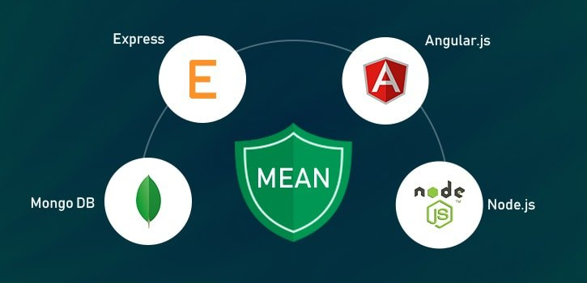

Image 1: MEAN Stack

Reference: <https://broadwayinfosys.com/blog/wp-content/uploads/2019/03/mean-stacks-main.jpg>

The MEAN stack is JavaScript-based framework for developing web applications. MEAN is named after **M**ongoDB, **E**xpress, **A**ngular, and **N**ode, the four key technologies that make up the layers of the stack.

* **M**ongoDB - document database
* **E**xpress(.js) - Node.js web framework
* **A**ngular(.js) - a client-side JavaScript framework
* **N**ode(.js) - the premier JavaScript web server

There are variations to the MEAN stack such as MERN (replacing Angular.js with React.js) and MEVN (using Vue.js). The MEAN stack is one of the most popular technology concepts for building web applications.

### How Does the MEAN Stack Work?

**MEAN Stack Architecture**

The MEAN architecture is designed to make building web applications in JavaScript and handling JSON incredibly easy.

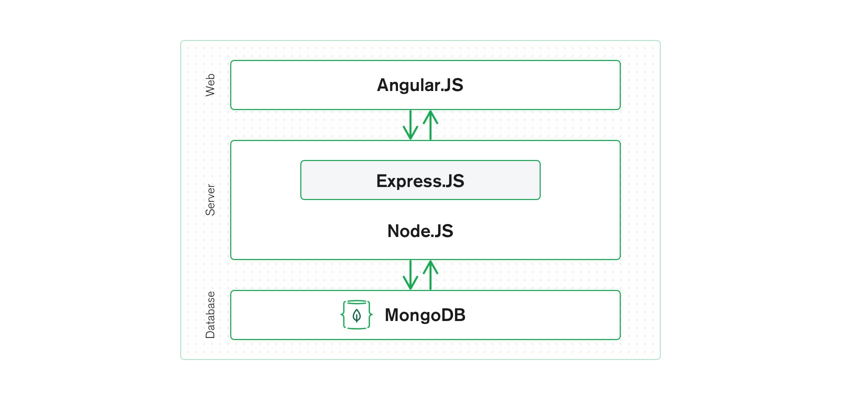

Image 2: MEAN Stack Architecture

Reference: <https://www.mongodb.com/mean-stack>

### MEAN Stack Components

**Angular.js Front End**

At the very top of the MEAN stack is Angular.js, the self-styled “A JavaScript MVW Framework” (MVW stands for “Model View and Whatever”).

Angular.js allows you to extend your HTML tags with metadata in order to create dynamic, interactive web experiences much more powerfully than, say, building them yourself with static HTML and JavaScript (or jQuery).

Angular has all of the bells and whistles you’d expect from a front-end JavaScript framework, including form validation, localization, and communication with your back-end service.

**Express.js and Node.js Server Tier**

The next level down is [Express.js](https://expressjs.com/), running on a Node.js server. Express.js calls itself a “fast, unopinionated, minimalist web framework for Node.js,” and that is indeed exactly what it is.

Express.js has powerful models for URL routing (matching an incoming URL with a server function), and handling HTTP requests and responses. By making XML HTTP requests (XHRs),r GETs, or POSTs from your Angular.js front end, you can connect to Express.js functions that power your application.

Those functions in turn use MongoDB’s Node.js drivers, either via callbacks or using Promises, to access and update data in your MongoDB database.

**MongoDB Database Tier**

MongoDB is a NoSQL database system. It is a cross-platform, documented oriented database which works on the concepts and the documents. It saves data in a binary format generally using JSON format which makes it easier to pass data between the client and the server.

If your application stores any data (user profiles, content, comments, uploads, events, etc.), then you’re going to want a database that’s just as easy to work with as Angular, Express, and Node.

That’s where MongoDB comes in: JSON documents created in your Angular.js front end can be sent to the Express.js server, where they can be processed and (assuming they’re valid) stored directly in MongoDB for later retrieval.

Again, if you want to easily get the best of MongoDB, you’ll want to look at [MongoDB Atlas](https://www.mongodb.com/cloud/atlas).

### Benefits of using Mean Stack

* It is often updated as it has open-source components.
* Developing web applications with Node.js is easy as it provides a good variety of JavaScript modules.
* Mean stack gives the developer a freedom to write code in only one language (JavaScript) for both client and server side that makes it a simple and fast language.
* Precisely flowing data among the layers of JSON does not require rewriting or reformatting as Mean uses common JSON format of data everywhere.
* Transfer of code from a particular framework to another framework is easy with Mean. Mean stack has become a leading end technology recently.
* Mean is highly flexible. Testing application on the cloud platform is easier after the successful completion of its development process. You can add extra information by just adding an extra field to your form.
* Development of apps with mean stack is less costly as it just requires developers who are proficient at javascript.
* Mean assists in the current period to develop real-time trending applications. Since it utilizes single-page applications (SPAs), There is no need to constantly update web pages for each server request.
* Mean saves a lot of time in developing applications because it has an infinite set of module libraries for Node.js which are ready for use.
* There is no time waste in creating modules from scratch. Time management is a huge benefit while in another hand, It also creates quality world-class applications.
* Mean supports MVC (Model View Controller) architecture.
* Mean Stack is very easy and flexible to understand which helps the developers to customize it as per requirements.
* Mean stack provides developers the feature to make website interactive by working on its appearances.
* In the back-end development too, the developers making the website more functional and is also provided by the mean stack.

Mean stack is improving daily and it is also easy to use. The leading development companies use Mean Stack for developing top mobile apps as Mean Stack is listed as the best technology for developing mobile apps. For most innovative web applications this is the most suitable technology.

### Disadvantages of Mean Stack

JavaScript is a modern language, and it wasn't initially designed to build backend servers. As the foundation of the MEAN stack is JavaScript, it adds a backend server that comes with concurrency and issues with performance that scales up due to JavaScript nature. As the development opportunities are rapid, the server logic would suffer from potential code and bad practices. The tool won't add concrete JS coding in the final terms, which is appropriate for the Stack. Which ultimately is suitable for one application might not work better for another.

* Once you develop the first site using a mean stack, it's hard to go back to the old approach.
* We don't find any specific general JS coding guidelines.
* It offers poor isolation of the server, therefore, chances of losing data.

### How secure is the MEAN stack?

We have a team of developers who highly recommend using Mean Stack with MongoDB Atlas. As Atlas comes with built-in credentials and end-to-end encryptions, it's the best foundation for securing MongoDB. Additionally, Mean Stack comes with concrete three-tier separation using best practices and correct network isolation. There are times when it prevents end-users from accessing the business logic and database layer. The application designed using this tool is the default to avoid malicious user interaction from putting your application at risk.

### Why choose Mean Stack?

* Scalable and Flexible
* Excellent Speed
* One Stack, one language
* Free of Cost
* User-Friendly
* Avoids Rewriting

# Introduction to Angular JS and UI benefits in Angular JS

## Introduction to Angular JS

AngularJS is an open-source Model-View-Controller framework (MVC) that is similar to the JavaScript framework. AngularJS is probably one of the most popular modern-day web frameworks available today. This framework is used for developing mostly Single Page applications. This framework has been developed by a group of developers from Google itself.

It can be added to an HTML page with a <script> tag. It enables us to create single-page applications that only require HTML, CSS, and JavaScript on the client side.

AngularJS extends HTML attributes with Directives and Data binding to HTML with Expressions.

### Angular Version History

* Google developed this web application framework in 2009. It is officially called AngularJS. Some people call this version Angular 1.0. This version came out on October 20, 2010.
* After Angular 1.0, in 2016, Angular 2 was released. It was written from scratch and is fully different from Angular 1 or JS.
* The third update, Angular 4, was launched in the year 2017. It is not a complete rewrite of the original version. Instead, it is the updated version of Angular 2.
* Angular 5 was released on 1st November 2017. The updates in this version help developers to create apps fast, as it removes unnecessary codes.
* Angular 6 was released on 3rd May 2018, and the version of Angular 7 was out in October 2018.
* Angular Team released Angular 8 on May 28, 2019. It features differential loading of all application code, web workers, supports TypeScript 3.4, dynamic imports for lazy routes, and Angular Ivy as an opt-in preview.
* Angular Team released Angular 9 on Feb 06, 2020. By default, version 9 moves all the applications to use the Ivy compiler and runtime.
* Angular 10 was released on Jun 24, 2020, with four months difference from the previous release.
* The latest angular version from Google is Angular 11. It was made available in the market from 14th November 2020.

### AngularJS Architecture

Angular.js follows the MVC architecture, the diagram of the MVC framework as shown below:

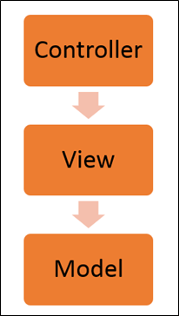

Image 3: Angular JS Architecture

Reference: <https://www.guru99.com/images/AngularJS/010416_0549_AngularJSIn1.png>

* The **Controller** represents the layer that has the business logic. User events trigger the functions which are stored inside your controller. The user events are part of the controller.
* **Views** are used to represent the presentation layer which is provided to the end users
* **Models** are used to represent your data. The data in your model can be as simple as just having primitive declarations. For example, if you are maintaining a student application, your data model could just have a student id and a name. Or it can also be complex by having a structured data model. If you are maintaining a car ownership application, you can have structures to define the vehicle itself in terms of its engine capacity, seating capacity, etc.

### Concepts of AngularJS

Few things you need to know to before starting with AngularJS:

* **Modules** - A module can be defined as a container that consists of various application parts. The module is a set of functions defined in a JavaScript file. Module divides an application into small and reusable components.
* **Directives** -Directives indicate the compiler to associate a behavior to the DOM element or modify it. Angular JS contains several directives such as ng-app, ng-controller, ng-view, ng-if, etc.
* **Expressions** -Angular JS expressions are expressed with {{ }} which indicate a data binding in HTML. These expressions can be added into the HTML templates. Expressions do not support control flow statements while support the filters.
* **Controller**- It is a JavaScript object constructor function that controls the AngularJS applications.
* **Scope**- It is a JavaScript object that acts as a bridge between the Controller and the View. It is the source of data in AngularJS. Each data manipulation and assignment takes place with the help of the Scope object.
* **Data Binding**- It coordinates the model and views any changes in either of these two.
* **Validations**- Validations take place with the help of AngularJS forms and controls.
* **Filters** -These let you display the formatting of data on DOM in Angular and extend the behavior of directives and binding expressions. Filters format the values or apply specific.
* **Services** -These are singletons that are used by directives, controllers, or other services.
* **Routing** -The service $routeProvider handles the operations of Routing. It divides the map into various views. It helps split the Single Page Applications into different views.
* **Dependency Injection**-It is a design pattern used to handle the dependencies of various components of a software. It lets you develop loosely-structured architectures.
* **Testing** -The codes developed by Dependency Injections are tested. Some of the popular testing frameworks like Jasmine and Karma are two widely-used technologies.

### Advantages of AngularJS

* It provides the capability to create Single Page Application in a very clean and maintainable way.
* It provides data binding capability to HTML. Thus, it gives user a rich and responsive experience.
* AngularJS code is unit testable.
* AngularJS uses dependency injection and make use of separation of concerns.
* AngularJS provides reusable components.
* With AngularJS, the developers can achieve more functionality with short code.
* In AngularJS, views are pure html pages, and controllers written in JavaScript do the business processing.

On the top of everything, AngularJS applications can run on all major browsers and smart phones, including Android and iOS-based phones/tablets.

### Disadvantages of AngularJS

* Not Secure − Being JavaScript only framework, application written in AngularJS are not safe. Server-side authentication and authorization is must to keep an application secure.
* Not degradable − If the user of your application disables JavaScript, then nothing would be visible, except the basic page.
* Complex at times – At times AngularJS becomes complex to handles as there are multiple ways to do the same thing. This creates confusion and requires considerable efforts.

### General features

* We can create rich internet application by using Angular JS.
* Angular JS Allow us to write the client-side code using Javascript in an MVC way.
* AngularJS provides cross-browser compliant and it automatically handles JavaScript code suitable for each browser.
* The AngularJS is Completely free and opensource it is used by thousands of developers all around the world.
* AngularJS is used to build high-performance, large scale, and easy-to-maintain web applications.
* AngularJS Directives: AngularJS is Javascript based framework and it may divide into three major part.
  + **ng-app**: By using this directive we can link AngularJS application to HTML.
  + **ng-model**: By using this directive we can bind the value of AngularJS application data to HTML input controls.
  + **ng-bind**: By using this directive we can bind AngularJS application data to HTML tags.

## UI benefits in Angular JS

The AngularJS framework employs basic HTML and offers extensions through directives that allow for the website to become more dynamic. Its capabilities to automatically synchronize with models and views make development on AngularJS an easy process. It exclusively follows DOM methodology, whose primary focus lies in improving application testability & performance. Therefore, the main features of AngularJS comprise; two-way data binding, templates, MVC structure, dependency injections, directives, and testing features.

Let’s take a look at some of the reasons for why AngularJS development companies leverage this framework for front-end product engineering

**Provides immense support to XAML Development**

XAML is an XML based markup language which is used to instantiate object graphs and set values. It allows you to define various types of objects with properties. It makes it easy to layout complex, ever changing UIs. It also supports for data-binding which allows a symbiosis between the presentation layer and your data without creating hard dependencies between its components. It also enables a developer to conduct any number of testing scenarios. AngularJS translates very well with XAML principles. It also allows a parallel workflow between different aspects that include the markup for the UI itself as well as the underlying logic that fetches and processes data.

**Provides a simplistic approach to data binding**

Data binding is very easy in the Angular world. The framework eliminates the need to derive from an existing object or place all your properties and dependencies cards on the table. AngularJS uses dirty tracking to enable this. Though several existing frameworks have evolved, the process of mapping everything explicitly to an interim object to data-bind to Angular is significantly easier and faster.

**Reduces application side-effects by allowing developers to express declarative UI**

Declarative UI has several advantages. A structured UI enables easy understanding and manipulation of the application. Using jQuery forces the developer to know a lot about the document structure which often creates two issues: first, a fairly unstable code working as “glue” that tightly grips the changes in the UI, and second, there is an uncertainty because it is hard to judge by studying the markup just how the UI would function. Placing markup directly in HTML, one can separate the presentation logic from imperative logic and keep it in one place. Understanding of the extended markup provided by Angular i.e. code snippets makes the whereabouts of the data amply clear. The addition, tools like directives and filters not only make the UI intent even more clear but also give clarity on how the information is being shaped.

**Simplifies testing**

AngularJS product engineering adeptly embraces Test-Driven Development, Behavior-Driven Development, or any of the driven-development methodologies of building an application. It helps in saving time and change the way an application is structured. Angular can help to test everything UI behavior to business logic with its ability to mock dependencies.

**Gives Design development workflow a new meaning**

Even though HTML and CSS support design, but AngularJS allows a developer to add a markup without completely breaking an application. It often depends on a certain id or structure to locate an element and perform tasks. Developers can rearrange portions of code by moving the elements around and the corresponding code that does the binding and filtering job moves with it.

**Makes Single Page Applications easy**

The growing popularity of Single Page Applications among AngularJS development companies is not unfounded as they cater to a very specific need. With more and more functionality finding its way to the web, developers are progressively realizing the potential of the browser as a distributed computing node. SPA boasts of more responsive design and can provide an experience of a native app on the web. AngularJS is an apt infrastructure that supports routing, templates, and even journaling making it viable accomplice of SPA.

Here are some additional advantages to leverage for awesome front-end product engineering:

* **Improved Plug & Play Features** – AngularJS makes it easy to add components from an existing application to a new application. It only needs a copy-paste command to make your existing assets available in a new environment.
* **Quicker Development Turnaround Time** – AngularJS supported by the MVC architecture ensures faster development, testing, and maintenance. The quicker turnaround time allows developers to enhance their productivity.
* **Superior Dependency Handling** – One of the biggest USPs of AngularJS is its “dependency injection”. Testing and Single Page Application have been enormously simplified because of the dependency injection feature.
* **Makes Parallel Development Possible** – Apart from faster development, AngularJS in collaboration with MVC architecture allows the developer to perform parallel application development which makes it stand-out amongst the competition.
* **Gives More Control to the Developers** – AngularJS directives give superior control to developers, who get a free hand to experiment with HTML and attributes. The directives allow them more independence to help them create more responsive platforms.
* **State Management Made Easy** – AngularJS helps you manage any application state easily whether it is illusioned or disillusioned. It is highly conducive when it comes to managing properties, permissions, and other major concerns across the application.

# Usage of Angular JS with HTML

AngularJS is a JavaScript framework. It can be added to an HTML page with a <script> tag. AngularJS extends HTML attributes with Directives, and binds data to HTML with Expressions.

AngularJS is a JavaScript framework written in JavaScript. AngularJS is distributed as a JavaScript file, and can be added to a web page with a script tag:



**AngularJS Extends HTML**

AngularJS extends HTML with ng-directives.

* The ng-app directive defines an AngularJS application.
* The ng-model directive binds the value of HTML controls (input, select, textarea) to application data.
* The ng-bind directive binds application data to the HTML view.

**AngularJS Example**

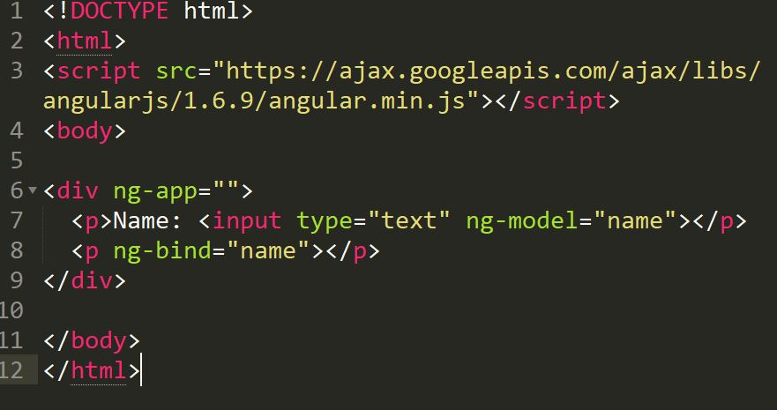

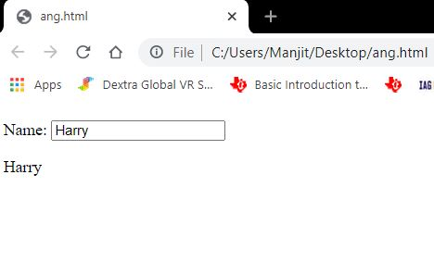

**Explanation:**

AngularJS starts automatically when the web page has loaded.

* The ng-app directive tells AngularJS that the <div> element is the "owner" of an AngularJS application.
* The ng-model directive binds the value of the input field to the application variable name.
* The ng-bind directive binds the content of the <p> element to the application variable name.

**AngularJS Directives**

As you have already seen, AngularJS directives are HTML attributes with an ng prefix.

The ng-init directive initializes AngularJS application variables.

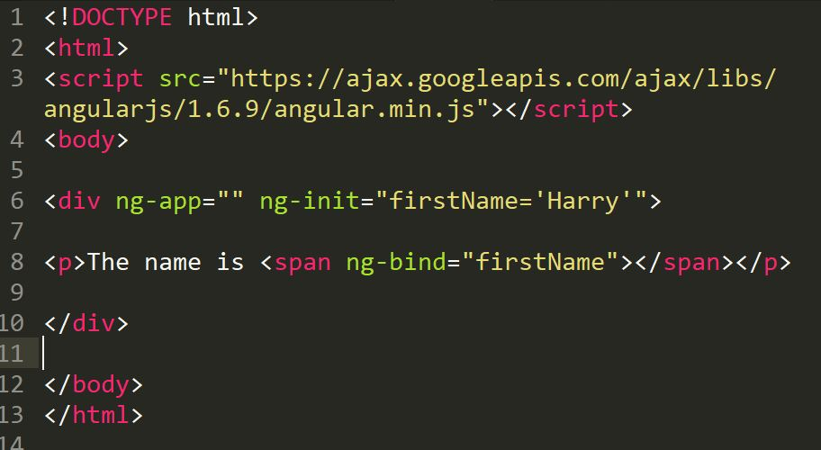



**AngularJS Expressions**

AngularJS expressions are written inside double braces: {{ expression }}.

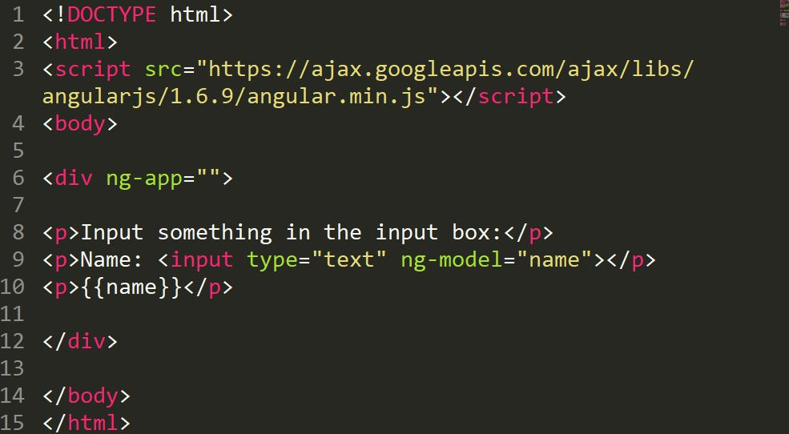

AngularJS expressions bind AngularJS data to HTML the same way as the ng-bind directive.

The ng-bind directive tells AngularJS to replace the content of an HTML element with the value of a given variable, or expression.

If the value of the given variable, or expression, changes, the content of the specified HTML element will be changed as well.

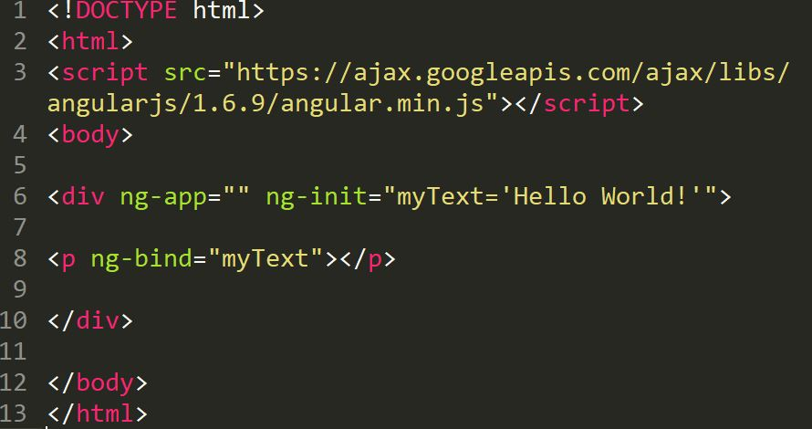

# Event Handling in Angular JS

## AngularJS Events

AngularJS includes certain directives which can be used to provide custom behavior on various DOM events, such as click, dblclick, mouseenter etc.

The following table lists AngularJS event directives.

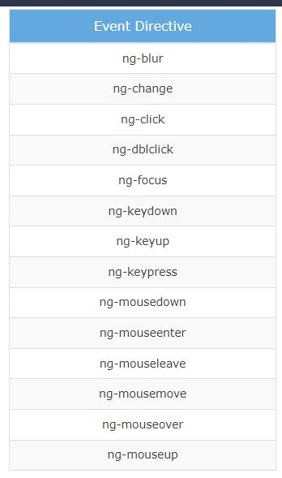

Image 4: Angular JS Event Directive

Reference: <https://www.guru99.com/images/AngularJS/010416_0549_AngularJSIn1.png>

* **ng-mousemove**: Movement of mouse leads to the execution of event.
* **ng-mouseup**: Movement of mouse upwards leads to the execution of event.
* **ng-mousedown**: Movement of mouse downwards leads to the execution of event.
* **ng-mouseenter**: Click of the mouse button leads to the execution of event.
* **ng-mouseover**: Hovering of the mouse leads to the execution of event.
* **ng-cut**: Cut operation leads to the execution of the event.
* **ng-copy**: Copy operation leads to the execution of the event.
* **ng-keypress**: Press of key leads to the execution of the event.
* **ng-keyup**: Press of upward arrow key leads to the execution of the event.
* **ng-keydown**: Press of downward arrow key leads to the execution of the event.
* **ng-click**: Single click leads to the execution of the event.
* **ng-dblclick**: Double click leads to the execution of the event.

Let's take a look at some of the important event directives.

**ng-click**

The ng-click directive is used to provide event handler for click event.

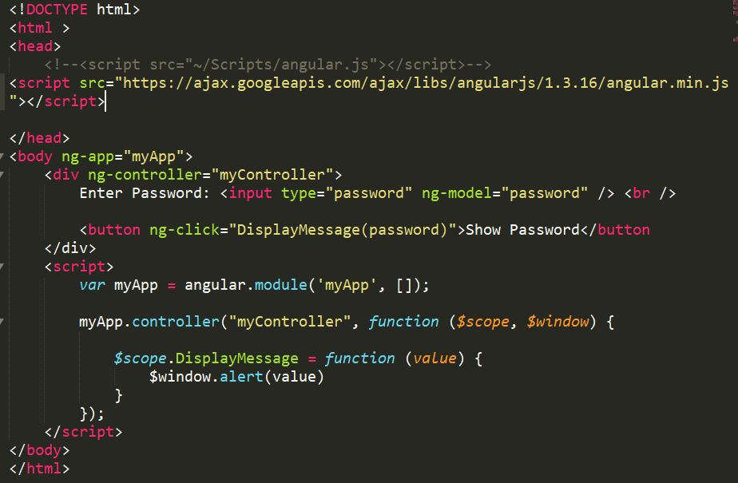

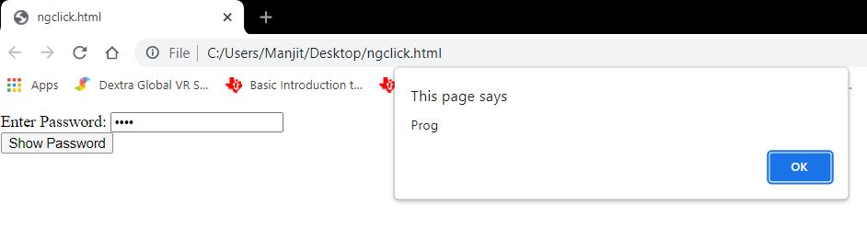

In the above example, ng-click directive is used to call a DisplayMessage() function with the 'password' parameter when a user clicks a button. A 'password' is a model property defined using ng-model directive in the input box. The DisplayMessage() function is attached to a $scope object in myController, so it will be accessible from button click as button comes under myController. The $window service is used to display an alert.

**Mouse Events**

The following example demonstrates important mouse event directives - ng-mouseenter and ng-mouseleave.

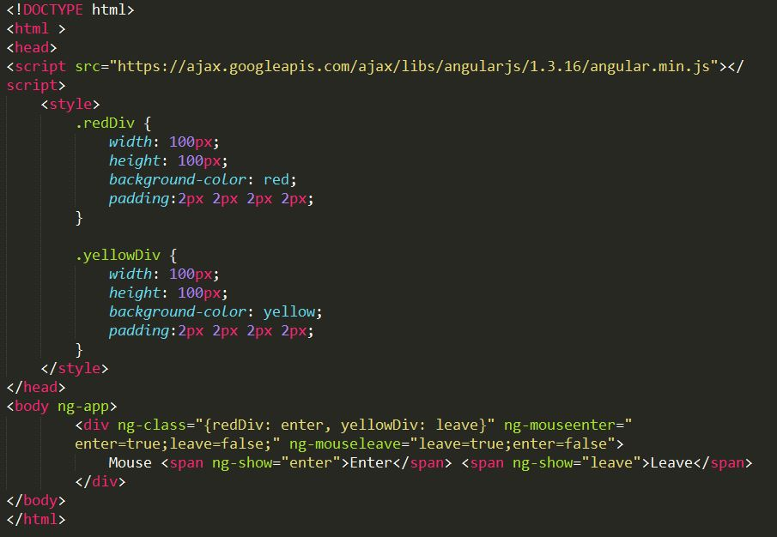

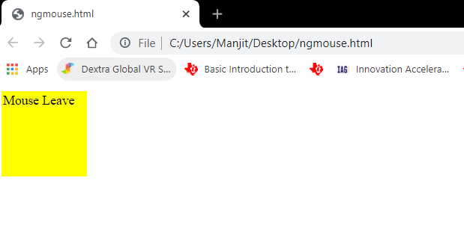

# Introduction Angular & difference b/w angular-1 and angular-5

## Introduction Angular

Angular is an open-source, JavaScript framework written in TypeScript. Google maintains it, and its primary purpose is to develop single-page applications. As a framework, Angular has clear advantages while also providing a standard structure for developers to work with. It enables users to create large applications in a maintainable manner.

Angular has many improvements over AngularJS. It has lots of innovations, which makes it easy to learn and develop enterprise-scale applications. You can build extendable, Maintainable, Testable and Standardized Applications using Angular.

**Features of Angular**

* Two-Way Data Binding - This is the coolest feature of the Angular. Data binding is automatic and fast. changes made in the View is automatically updated in the component class and vice versa
* Powerful Routing Support - The Angular Powerful routing engine loads the page asynchronously on the same page enabling us to create a Single Page Applications.
* Expressive HTML - Angular enables us to use programming constructs like if conditions, for loops, etc to render and control how the HTML pages.
* Modular by Design - Angular follows the modular design. You can create Angular modules to better organize and manage our codebase
* Built-in Back End Support - Angular has built-in support to communicate with the back-end servers and execute any business logic or retrieve data
* Active Community - Angular is Supported by google and has a very good active community of supporters. This makes a lot of difference as your queries are quickly resolved.

Angular has changed massively from the AngularJS. Angular completely redesigned from scratch. There are many concepts AngularJS that have changed in Angular.

### Top 12 Angular Features:

**1. Cross-platform**

It is imperative to have this factor first on the Angular features list because Angular plays a prominent role in developing Progressive Web Applications (PWA). With PWA by your side, audiences can enjoy an app-like experience using contemporary web capabilities. Most importantly, with this feature, you can deploy a local or a progressive app.

**2. Efficient MVC architecture**

The Model-View-Controller (MVC) architecture is among the leading Angular 8 features. MVC enhances the worth of the framework for client-side application development and takes care of other features like data binding and scopes. As compared to other frameworks, MVC blends in all the necessary elements of the application to waive off extra coding.

**3. Sectional structure**

The best part about the Angular framework is it helps in organizing code into different modules as and when you build them. Due to this feature, there is a division of overall functionality into reusable code. Furthermore, this helps in the division of tasks among the Angular developers and permits web applications to accomplish lazy loading.

**4. The eminence of Angular CLI**

Angular’s Command Line Interface (CLI) is a boon for web development. CLI helps in automating certain processes with simple commands. You may add or remove defined functionalities with a combination of these simple commands. In addition, it enables running units’ tests and end-to-end tests swiftly. All these AngularJS features enhance the code quality considerably.

**5. Data binding**

With data binding by your side, a user can easily manipulate web page elements through a web browser. It utilizes dynamic HTML and waives off intricate scripting or programming. Data binding plays a vital role when coming up with web pages equipped with interactive components, like games, tutorials, etc. Also, when a web page has way too much data, it enables a better display.

Besides, a model is a place where you make edits in the application. Those changes are reflected in UI elements. When the model changes, the developer supposedly has to make manual edits in the DOM elements, and then the attributes start reflecting. It is a cumbersome task, but Angular eliminates it with two-way data-binding. This process helps in synchronizing the DOM and the model, and vice versa.

**6. Set of Directives**

AngularJS expands the functionality of HTML with a set of inbuilt attributes, also known as directives. The imperative functionality of these directives is to boost the competence of HTML. With this, it becomes immensely appropriate for dynamic client-side applications. The best part is these directives can be self-initiated using AngularJS.

**7. Prominence of TypeScript**

TypeScript is the superscript of JavaScript. The main advantage of using TypeScript is you can detect and correct errors in the code while writing. It also supports AngularJS security features like primitive and interface. Interestingly, Angular is written using TypeScript and boasts all these features.

**8. Declarative UI**

One of the AngularJS key features is declarative UI. In Angular, you can skip using JavaScript to outline the UI of your web application and instead use HTML as it is less complicated than JavaScript. HTML is a blessing for Angular applications as it imports declarative and intuitive properties of the UI components. With properties like these, you don’t have to initiate manual program flows. Instead, you can simply describe the page layout and the path of the data. Further, Angular declarative UI takes care of the components as per the layout. With this, ample time and effort are saved in front-end development.

**9. Extensive documentation and support**

Google supports Angular because of the stability of the framework. Most importantly, Google has enriched the Angular community with documentation and tools to build functionalities and resolve issues. Due to these reasons, a developer is never helpless in the Angular community. The answers are readily available either in the documents or in the online forums.

**10. The prowess of Ivy Renderer**

A renderer helps in translating a code written in TypeScript and HTML into standard JavaScript instructions. With this, it helps the browser to interpret. Renderer makes your components and templates understandable for the browser to display them aptly. Furthermore, with its tree shaking technique, Ivy Renderer removes unused code, making the web application smaller and boosting its loading speed. All in all, this feature reduces the size of the Angular framework and makes the bundle a bit smaller.

**11. Test-friendliness**

JavaScript is an interpreted language, which makes it imperative for developers to test the code capability. But while using AngularJS, developers are unhindered by this requirement. The framework has features like Dependency Injection (DI) that supports testing. DI simplifies the entire process where the testers must insert the test data in the controller and parallelly check the output. It’s that simple!

**12. Timely upgradations**

If you don’t upgrade your framework from time to time, you may lag in this race of the digital world. New settings pour in, and if they are absent, your application will be tagged as outdated. To eliminate this problem, Angular improves its Component Development Kit (CDK) on a timely basis. It not only enhances but also takes care of the angular version upgrades.

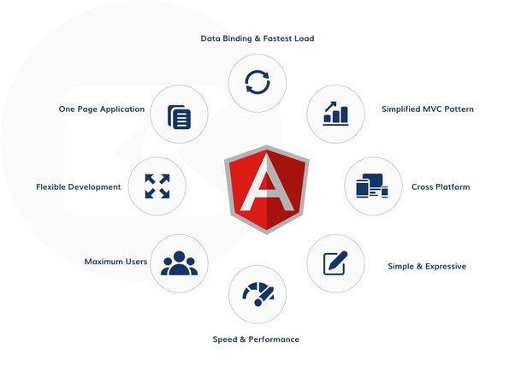

Image 5: Angular Features

Reference: <https://qph.fs.quoracdn.net/main-qimg-3d2a60f972904b5dd34a3f99a31dc0c2-lq>

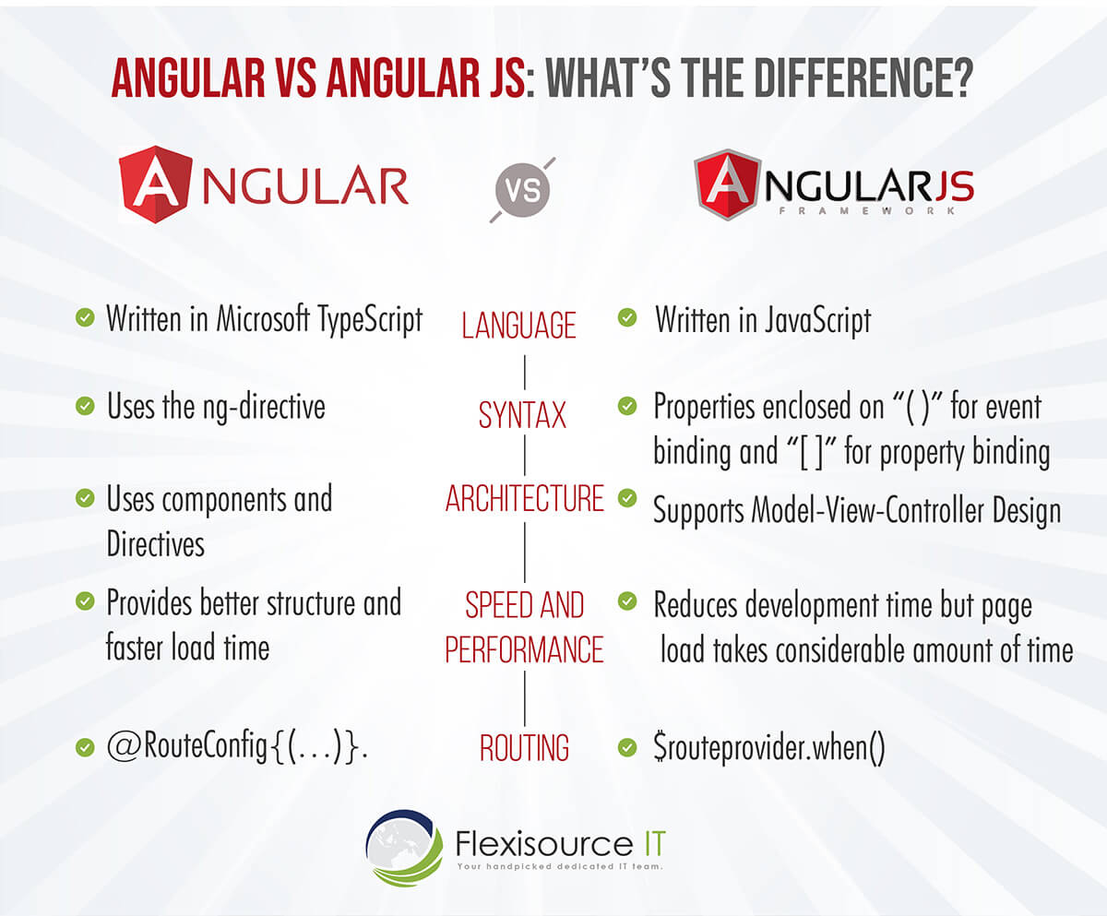

Image 6: Difference between Angular Vs AngularJS

Reference: <https://qph.fs.quoracdn.net/main-qimg-3d2a60f972904b5dd34a3f99a31dc0c2-lq>

Likewise, let’s take a look at the more detailed distinction between AngularJS and Angular:

**1. Programming Language**

One vital difference between Angular and AngularJS is that Angular is based on Typescript Langue and Angular JS is Javascript based. Angular can also be used in other languages such as ES5, ES6, and Dart to write codes. On the other hand, AngularJS is solely Javascript-based. Still, developers can use the features such as declarative template language using HTML, which is intuitive.

**2. Expression Syntax**

While both Angular and AngularJS use directives, Angular has a standard directive, and Angular has a pack of them. When it comes to data binding, Angular is more intuitive than AngularJS. Angular uses () and [] to bind data and attributes between view and model. In the case of AngularJS, the ng-model is used to bind data. {{ }} expressions are applied for two-way binding among view and model.

**3. Web Architecture**

AngularJS supports Model-View-Controller design that acts as the main component in managing data, rules, logic and expresses how the application behaves. In addition, the Model-view-controller design processes the data presented in the model to produce the output.

On the other hand, Angular uses components and directives with templates. Angular directives are divided into two kinds, structural directives and attribute directives. Structural directives alter the DOM’s layout by changing its elements. Meanwhile, attributes directive changes DOM’s behavior and appearance.

**4. Speed and Performance**

Since Angular provides a better structure, the framework offers improved performance and structure. In addition, it’s easier to create and maintain big applications. To date, Angular 4 is the fastest version of the framework.

Likewise, Angular JS also reduces development effort and time with the two-way binding features. However, creating more processing on the client-side of programs can slow down page load time.

**5. Routing**

AngularJS uses $routeProvider.when() to provide routing information and configuration. On the other hand, the Angular framework uses a simple path. Developers can use URLs to imitate directives to get to the client view or use @RouteConfig{(…)} for routing information, giving this framework an edge over AngularJS.

**6. Mobile Friendliness**

When it comes to mobile-friendliness, AngularJS does support mobile while Angular is great for mobile. Due to its dynamic web and single-page scripts, Angular is exceptionally mobile-friendly. On the other hand, AngularJS’s simple architecture and code cannot support mobile applications.

**7. Dependency Injection**

AngularJS doesn’t employ dependency injection and uses directives instead. Angular uses unidirectional change detection and hierarchical dependency injection to boost the framework’s performance.

**8. Management**

Angular projects are more straightforward to manage than AngularJs due to how structured it is. AngularJS can be difficult to work with as the size of the source code increases. On the other hand, Angular code has a better structure. It is easy to scale and manage as the application becomes more extensive. This is a great advantage when developing big applications.

**9. Testing and Tools**

AngularJS includes a ready unit testing feature called IDE and Webstrorm, a third-party JavaScript tool. These tools can be used by developers in building applications and finding defects in their designs. On the other hand, Angular uses Command Line Interface (CLI) for developing and serving angular applications. It helps developers in reducing development time, creating and testing accessibility, and more.

**10. SEO**

When it comes to web optimization strategies, Angular has inbuilt extensions for rendering server-side applications. This lets developers synchronize both server-side and client content, which is excellent for SEO. In the past, Google did not crawl properties of pages made in JavaScript. But in 2014, Google updated its AI and announced the inclusion of JavaScript. Today, AngularJS can also be SEO friendly but requires processes like avoiding using # in URLs, using a limited number of embedded resources, and more.

## Difference b/w Angular-1 to Angular-5

|  |  |
| --- | --- |
| **Angular 1** | **Angular 5** |
| Released by Google in the year 2010. | Released by Google in the year 2017. |
| JavaScript-based framework for creating SPA. | Angular 5 comes with build optimizer which is a part of the platform’s command like a tool. |
| Still supported but no longer will be developed. |  |
| The architecture of AngularJS is based on MVC. |  |
| AngularJS was not developed with a mobile base in mind. |  |
| AngularJS code can write by using only ES5, ES6, and Dart. | Compiler Improvements |
| Based on controllers whose scope is now over. | New Router Lifecycle Event |
| Factory, service, provider, value and constant are used for services | Optimization with HTTP Client Feature Internationalized Date & Currency |
| Run on only client-side |  |
| ng-app and angular bootstrap function are used to initialize |  |

**Angular JS**

AngularJS is the official name, but some developers also refer to this as Angular 1. It is a front-end and open-source web application framework based on JavaScript. It uses HTML as a template in this framework. In AngularJS, the data and expressions are merged to create an expressive environment for developing web applications quickly. It simplifies both the testing and development of applications by providing a framework for client-side model–view–controller (MVC) and Model–View–ViewModel (MVVM) architectures, along with components commonly used in rich Internet applications.

It uses the controller approach where the view communicates using a $scope.

**Angular 5**

Angular 5 is more advanced and has more enhanced features than Angular 4. The best feature of Angular 5 is that it aids developers in removing unnecessary codes from their applications.

Other improved features are a code-sharing feature, less time for assembling dynamic web applications, and so on. Moreover, it has DOM support, and its compiler helps with incremental compilation.

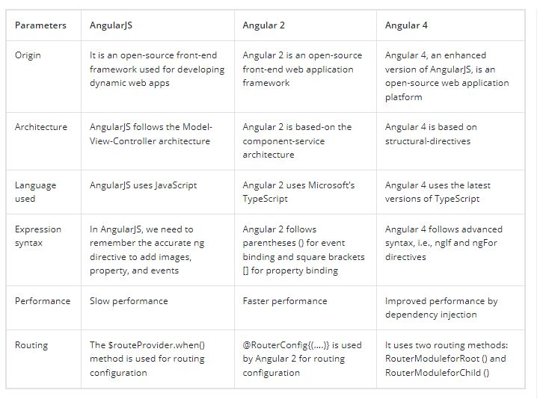

Image 7: Difference between Angular 1 TO 4

Reference: <https://qph.fs.quoracdn.net/main-qimg-3d2a60f972904b5dd34a3f99a31dc0c2-lq>

References

1. <https://www.mongodb.com/mean-stack>
2. <https://www.guru99.com/angularjs-introduction.html>
3. <https://www.w3schools.com/angular/angular_events.asp>